FACT TABLE :

DETAILED MAPPING :

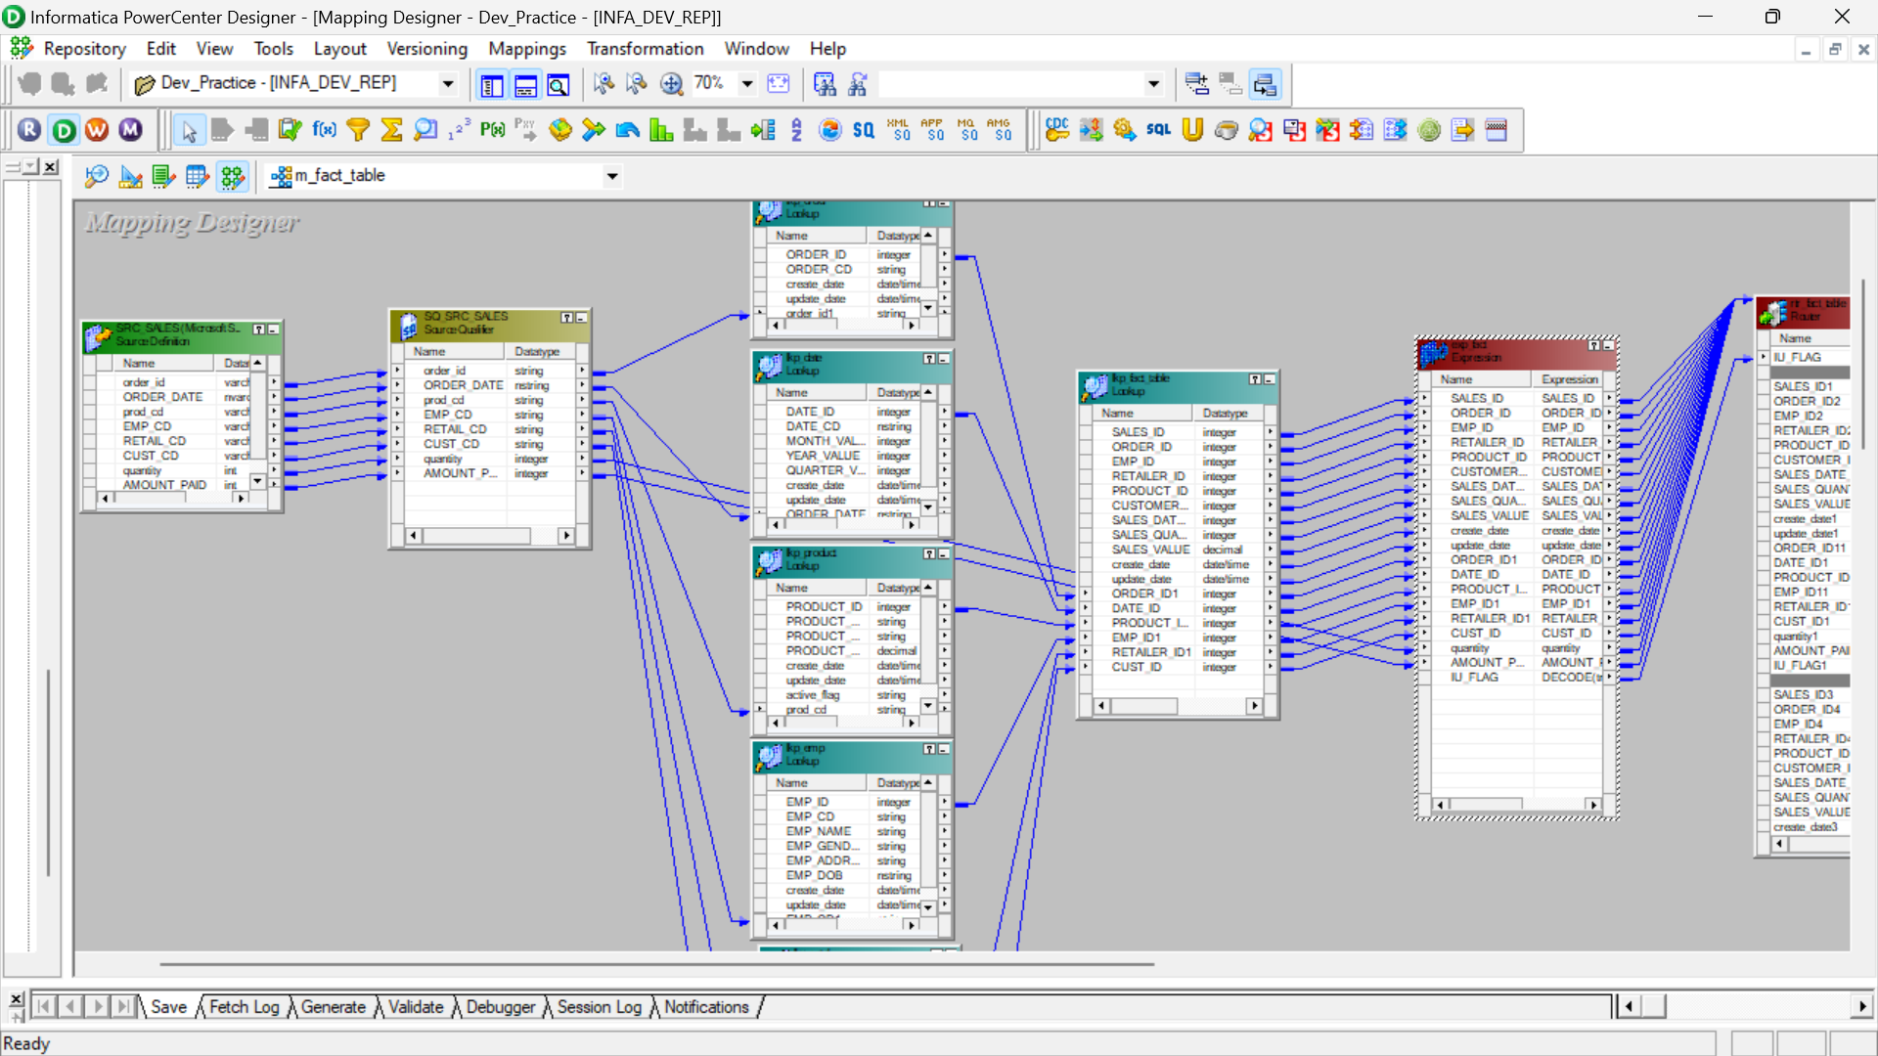

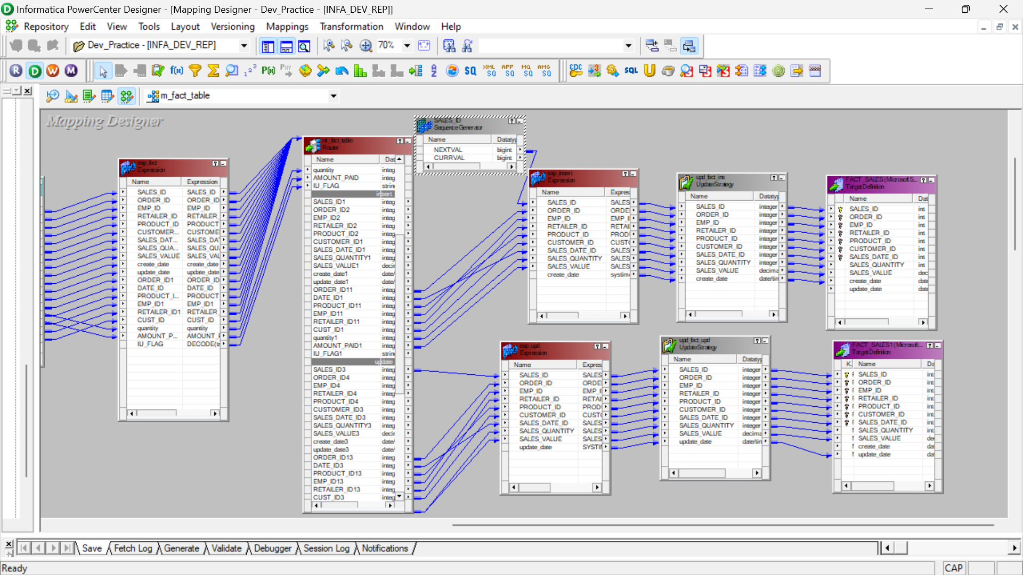

OVERALL MAPPING :

WORKFLOW MANAGER:

OUTPUT SCREENSHOT :

A total of 209 rows got affected.

